

Project laboratory report
Department of Telecommunications and Artificial Intelligence

Name: | Balázs László Bognár
Neptun code: | RA7X78
Specialization: | Information Systems
Email: | bognarbalazslaszlo2007@gmail.com
Supervisor(s): | Toka László, Szmida Patrik Péter
Email(s): | toka@tmit.bme.hu szmida.patrikpeter@edu.bme.hu

Title: League of Legends Analytics

Task description
Esports and competitive gaming have experienced explosive growth in recent years, now attracting a global audience of tens of millions. While data analysis and artificial intelligence methods are already established practices for developing players and teams in traditional sports, their application in gaming is currently emerging. This is particularly true for League of Legends (LoL), which is one of the most popular titles today.
In this project, the student's task is to familiarize themselves with the methodology of collecting and processing data generated during matches, focusing specifically on Korean Challenger ranked players rather than professional esports matches. The student will analyse player and team performances using machine learning techniques. The emphasis is on building a complete AI-based analysis pipeline, from data scraping and preparation via the Riot Games API to exploratory data analysis (EDA) and predictive modelling, with a special focus on calculating win probabilities based on sequential in-game events.

2025/2026. 2nd semester

Introduction and Background

1.1 Introduction
In recent years, esports have exploded, and large quantities of match data are stacking up every day. Traditional sports teams already use data analytics to a certain extent, but in esports people are just starting to scratch the surface, even though the games produce a ton of detailed, well-structured data [2] [3].
League of Legends represents a notable exception in this context. Due to its complex game design and the wide range of measurable in-game features, it provides a particularly valuable environment for analytics. A key question that attracts considerable attention is how to estimate a team’s probability of winning as the match progresses [4]. Addressing this requires tracking how events and evolving game states shift the odds in favor of one team or the other. Therefore, the analysis must capture both the temporal progression of the game and the interaction among numerous variables.
This project focuses on matches played by Challenger-level players on the Korean server. This dataset captures the top tier of ranked gameplay. Here, players push their strategies to the limit and their mechanical skills stay sharp, so you don’t see as many random or sloppy mistakes. That gives the data real clarity—you can pick out patterns that actually mean something, not just noise. The Korean server stands out, too. Players there have a reputation for being fiercely competitive, which makes this data especially valuable for analysis.
The motivation for this research stems from a profound interest in the strategic complexities of competitive esports. By leveraging comprehensive domain knowledge of League of Legends mechanics and macro-strategies, this project applies rigorous data science methodologies to analyse high-level gameplay. The primary objective is to develop a robust machine learning model capable of accurately estimating real-time win probabilities. Furthermore, the study aims to systematically quantify the underlying in-game factors and critical events that determine the ultimate outcome of a match.

1.2 Theoretical Background
In a League of Legends match, two teams of five play against each other, aiming to take down the enemy’s Nexus—the heart of their base. Every player picks a champion and sticks to a role: top, jungle, mid, attack damage carry (ADC), or support. The teams battle it out on a map split by three lanes, with towers and objectives waiting in between. Most of the stats and data people analyse come from solo queue games. However, due to the inherent lack of established communication channels and prior team cohesion, these matches typically exhibit limited macro-level coordination and structured teamwork.
From a data analysis perspective, match outcome prediction can be formulated as a supervised machine learning problem. In this setting, models are trained on historical match data to learn the relationship between in-game features and the final outcome. This can be tackled in multiple ways. Sometimes, it’s framed as a classification problem: the goal is to predict which team wins. Other times, it’s treated as a probabilistic estimation problem, where the model predicts the likelihood of a win from a given game state.
Win probability can therefore be formally interpreted as the conditional probability of a team winning given the current game state. Unlike static prediction tasks, this probability evolves throughout the match as new information becomes available. The input to such models typically consists of aggregated in-game metrics, such as resource differences, objective control, and other state descriptors [7].
A defining characteristic of League of Legends data is its temporal structure. The relevance of individual features varies across different stages of the game. Early-game advantages, such as initial gold leads, may not directly determine the outcome but can influence later developments.

1.3 Initial State of the Project
At the beginning of the project, no pre-processed or directly usable dataset was available for the intended analysis. In particular, access to detailed professional esports data is limited, and publicly available datasets often lack the granularity or consistency required for reliable modelling. As a result, it was necessary to collect and construct a suitable dataset independently.
Due to these limitations, the focus was shifted from professional esports matches to high-level ranked gameplay. Data collection was therefore based on matches played by Challenger-level players, which provide a comparable level of gameplay quality while being more accessible through public data sources. At the initial stage, no data processing pipeline or predictive model was implemented, and the project started with the design of a data acquisition and preprocessing workflow.

Methodology and Results

2.1 Data Scraping and Preparation
The dataset used in this project was constructed using the Riot Games API [1], which provides access to detailed match and player data. Due to strict rate limiting constraints imposed by the API, data collection had to be performed in a controlled and incremental manner. Requests were organized in batches, with intermediate results stored locally to ensure robustness and to avoid data loss during long-running scraping processes.
The data collection process began with retrieving Challenger-level ranked ladders from the Korean server (Figure 1). From these ladders, individual player identifiers were extracted, which were then used to obtain match histories. For each match, both general match data and detailed timeline data were collected. The timeline data is particularly important, as it provides fine-grained information about in-game events and state changes over time. The automated data collection and processing architecture is systematically visualized in Figure 1, tracking the transition from raw API queries to structured match records.
Figure 1: The automated data collection and processing pipeline

During the initial phase of development, a prototype dataset was constructed using a simplified representation, where match states were sampled at fixed one-minute intervals. While this approach allowed for a basic temporal analysis, it resulted in a loss of important information between sampling points. To address this limitation, the final dataset was built using an event-driven approach, where each recorded row corresponds to a specific in-game event or timestamp. This method preserves the full temporal resolution of the match and enables more accurate modelling of game dynamics.
The final dataset structure includes the match identifier, temporal information (both minute-based and exact timestamps), and detailed player statistics for all ten participants. In addition to raw features, cumulative statistics and difference-based features were also computed, such as team-level aggregates and inter-team differences. These derived features play a key role in capturing relative advantages between teams. The structural impact of early-game objective control and spatial layout can be directly observed in Figure 3, which maps the detailed distribution of player positions at the 15-minute threshold.
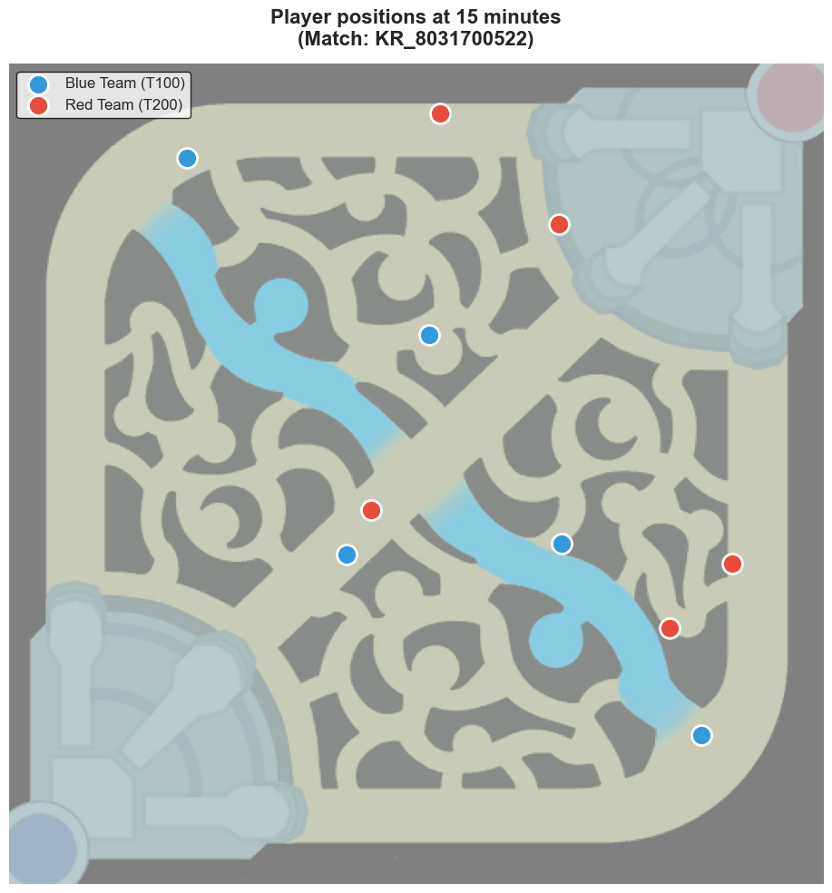
Figure 2: Spatial distribution of player positions at the 15-minute mark
Data collection was performed in multiple batches, which were later merged into a unified dataset. The final dataset consists of 10,223 matches and several million rows due to the event-driven representation. Initially, approximately 704 features were generated from match and timeline data. In a later stage, additional champion-specific features were incorporated, increasing the total number of features by 344 and further enriching the dataset.
Due to the high dimensionality of the final dataset (1,048 features), representing every single column is impractical. Instead, the event-driven feature architecture is systematically categorized into five core groups:
- Identifiers & Temporal Data: Contextual information defining the match, exact timestamp, and the trigger event (e.g., matchId, timestamp, type).
- Individual Player Statistics: Real-time metrics for all 10 participants at the exact moment of the event (e.g., currentGold_p1, positionX_p1).
- Team Differential Metrics: The computed numerical difference between the Blue and Red teams (e.g., totalGold_diff, xp_diff, level_diff).
- Cumulative Events: Running differential totals of significant game events up to the current timestamp (e.g., cum_CHAMPION_KILL_diff).
- Champion Features: One-hot encoded representations of the specific champions selected by each team.

2.2 Exploratory Data Analysis (EDA)
Exploratory data analysis was performed on a representative subset of the collected data, consisting of approximately 2.6 million rows, 704 features, and 2,475 matches. This reduced dataset enabled efficient analysis while preserving the statistical properties of the full dataset.
The distribution of match durations reveals a noticeable concentration around the 15-minute mark, which corresponds to early surrender conditions in ranked matches. As illustrated by the match duration distribution in Figure 3, a noticeable concentration appears around the 15-minute mark, which corresponds to early surrender conditions in ranked matches. This confirms that a non-negligible portion of games ends prematurely, which has implications for both feature interpretation and model training.
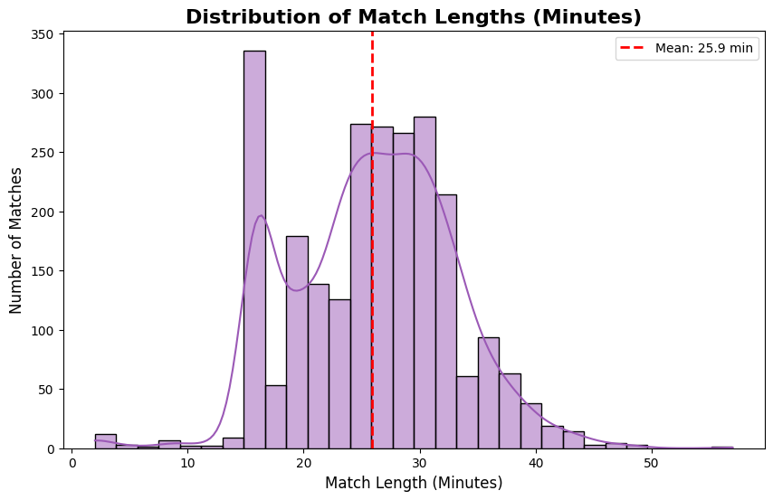
Figure 3: Distribution of match durations showing the 15-minute surrender spike

Key gameplay-related features, such as gold difference and experience (XP) difference between teams, were analysed in detail. These variables show strong correlation with match outcomes and exhibit clear distributional differences between winning and losing teams. In particular, gold advantage emerges as one of the most informative indicators of game state, supporting its use as a primary feature in predictive modelling.
To further investigate feature relationships, correlation analysis was conducted on a selected subset of relevant variables. The resulting heatmaps highlight strong dependencies between resource-based and objective-based features, while also revealing redundancies among certain derived metrics. This analysis informed later feature selection and engineering steps.
Furthermore, the data confirms a persistent statistical phenomenon known as the "Blue Side Advantage." Analysing the global win rates in the sample, the Blue team exhibited a slight but statistically significant higher win probability compared to the Red team. This is historically attributed to map asymmetry, camera angle perspectives, and the pick/ban phase drafting order.
Objective control, particularly in the early stages of the game, also shows a meaningful relationship with match outcomes. Early acquisition of objectives such as dragons or towers is associated with increased win probability, although their impact is typically mediated through resource advantages gained over time.
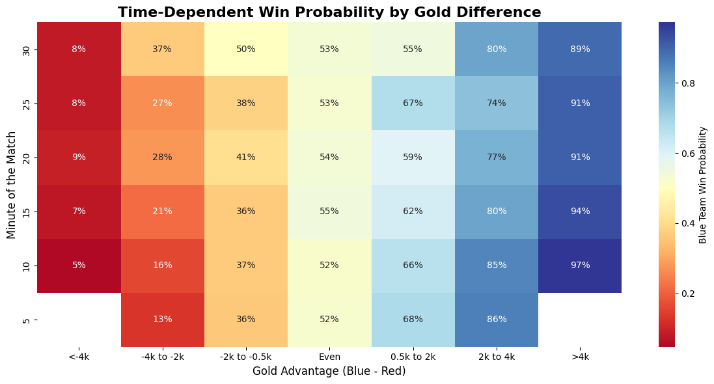
Finally, the temporal aspect of the data was examined by analysing how the relationship between gold difference and win probability evolves throughout the match. This can be seen at Figure 4. The results indicate that the predictive power of gold advantage increases as the game progresses, reinforcing the importance of time-dependent modelling approaches.
Figure 4: Heatmap of time-dependent win probability based on gold difference

2.3 Predictive Modelling for Win Probability
To estimate win probability based on in-game features, several machine learning approaches were implemented and evaluated. The modelling process was designed to compare both simple baseline methods and more advanced techniques capable of capturing nonlinear relationships and temporal dependencies.
As an initial baseline, logistic regression was applied to a reduced subset of the dataset, consisting of approximately 1 million rows and 921 matches. This model provides a straightforward probabilistic interpretation and serves as a reference point for more complex approaches. However, due to its linear nature, its ability to capture interactions between features is limited. [7]
To address these limitations, gradient boosting methods were introduced, specifically using XGBoost [5]. This approach is well-suited for tabular data and can effectively model nonlinear relationships between features. Two variants were implemented: one using only gameplay-derived features, and another extended with champion-specific features. Crucially, to accommodate the significantly increased feature space and to capture complex composition-related effects, this champion-aware XGBoost variant was trained on the entirety of the merged dataset, encompassing over 10 million event rows across all 10,223 matches. The inclusion of champion information increased the feature space significantly and allowed the model to capture composition-related effects.
Hyperparameter optimization was performed using grid search to improve model performance. In addition to standard evaluation metrics, calibration of predicted probabilities was also examined. Calibration plots were used to assess how well the predicted probabilities correspond to actual observed outcomes, which is particularly important in the context of win probability estimation. The reliability and probabilistic accuracy of the model's predictions are explicitly evaluated through the calibration plot presented in Figure 5.
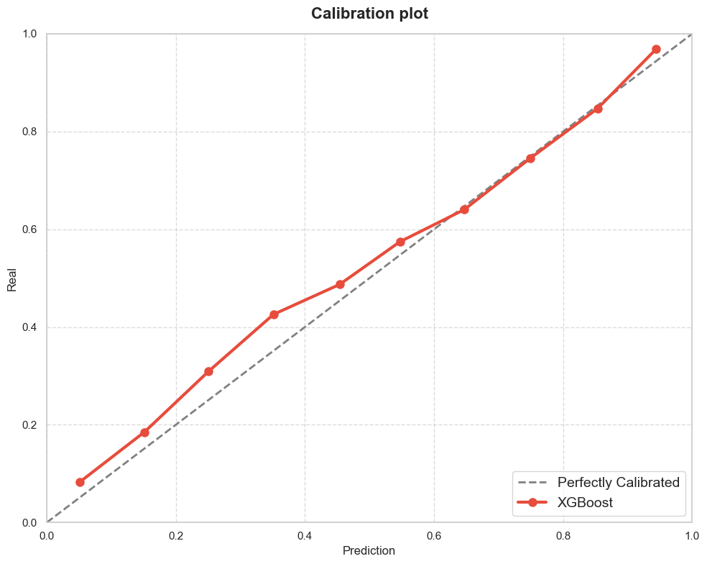

Figure 5: Calibration Plot of the XGBoost model showing the reliability of predicted probabilities

To further incorporate the temporal nature of the data, a sequence-based model using Long Short-Term Memory (LSTM) [6] networks was implemented. This model was trained on approximately 2 million rows and is capable of learning patterns from sequences of game states rather than independent observations. By modelling temporal dependencies explicitly, the LSTM approach aims to improve prediction quality, especially in earlier stages of the game where static features may be less informative.
The performance of the models was evaluated using standard classification metrics, with particular emphasis on probabilistic interpretation and temporal consistency. The results demonstrate that tree-based methods outperform linear models in terms of predictive accuracy, while the inclusion of temporal modelling provides additional improvements in capturing game dynamics.

2.4 Results and Evaluation
Table 1: Summary of predictive performance metrics across the evaluated machine learning architectures.
Model | Features | Train rows | Accuracy | ROC-AUC
Logistic regression | 685 | ~1 million | 71,39% | 0,7910
XGBoost  (no champions) | 685 | ~1 million | 72,18% | 0,7951
XGBoost  (with champions) | 1032 | ~10 million | 71,45% | 0,8001
LSTM (sequential) | 685 | ~2 million | 56,18% | 0,6049
LSTM (optimized) | 685 | ~2 million | 60,22% | 0,6462

We assessed how well the models’ predicted outcomes by using solid statistical measurements, with a special focus on classification accuracy and ROC-AUC. When we first trained the Extreme Gradient Boosting (XGBoost) model on just the 685 core game state features—covering all sorts of economic details, spatial arrangements, and objectives—we saw impressive results. This setup alone reached a test accuracy of 72.18%, which gave us a strong baseline to work from.
While these results were promising, the original setup didn’t fully reflect the deeper tactical layers that come with champion drafting and selection. Recognizing this, we took the model further. We added 344 one-hot encoded champion features to capture the impact of draft choices, which bumped the total feature count to 1,032. By letting the model see not just the game’s numbers and positions but also who was actually in play, we saw an unmistakable boost in performance. Accuracy decreased to 71.45%, and the ROC-AUC score maintained a 0.8001.
A comprehensive feature importance analysis was conducted to interpret the internal decision-making processes of the optimized XGBoost model. As anticipated, macroeconomic indicators unequivocally dominated the predictive weighting, with the total gold difference (totalGold_diff) emerging as the single most critical feature across all stages of the match. The absolute weights and relative strategic influence of these structural indicators are quantified in the feature importance chart shown in Figure 6. However, the analysis also confirmed that the incorporation of champion-specific data significantly refined the model's confidence intervals. While gold accumulation dictates the primary game state, the presence of specific champions provides the model with crucial context.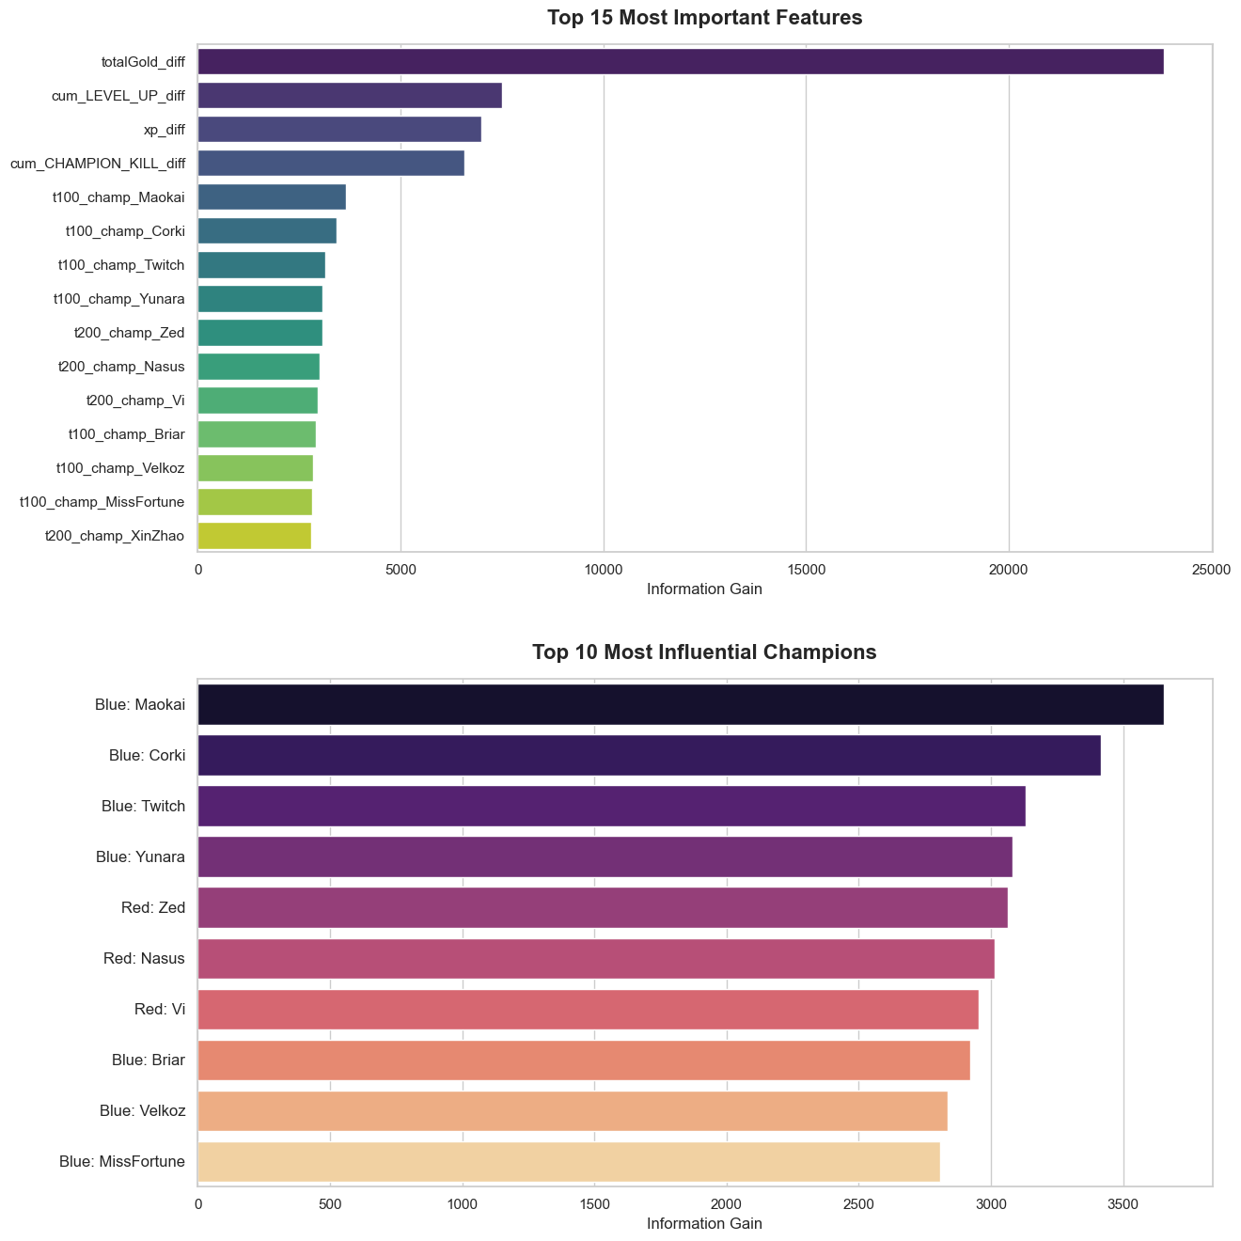
Figure 6: Relative feature importance extracted from the optimized XGBoost model, highlighting the dominance of macroeconomic indicators alongside specific champion selections
Instead of settling for broad, minute-by-minute averages, the model scrutinizes the game at each exact millisecond where something important happens—a champion kill, an objective capture, or similar events. This ultra-fine temporal focus lets the model adjust win probability right as momentum changes, without delay. That means the trajectory of predictions isn’t just a smoothed-out curve; it reacts in real time to each pivotal event. Looking at the data one timestamp at a time, the model captures how chaotic and unpredictable matches can get, picking up the immediate consequences of a skirmish, a key pickoff, or some other localized event long before that impact would appear in aggregated numbers. This granular, highly responsive tracking capability is clearly demonstrated by the real-time prediction trajectory depicted in Figure 7.

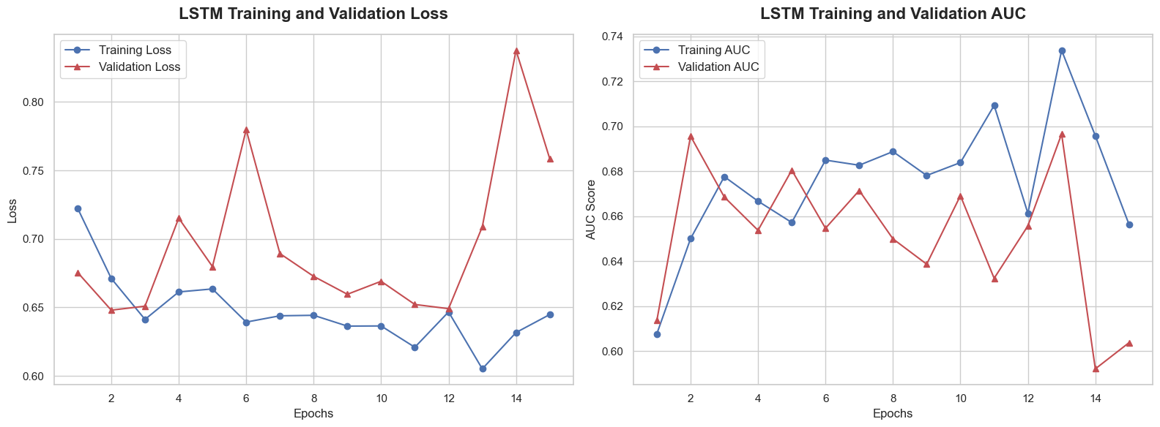
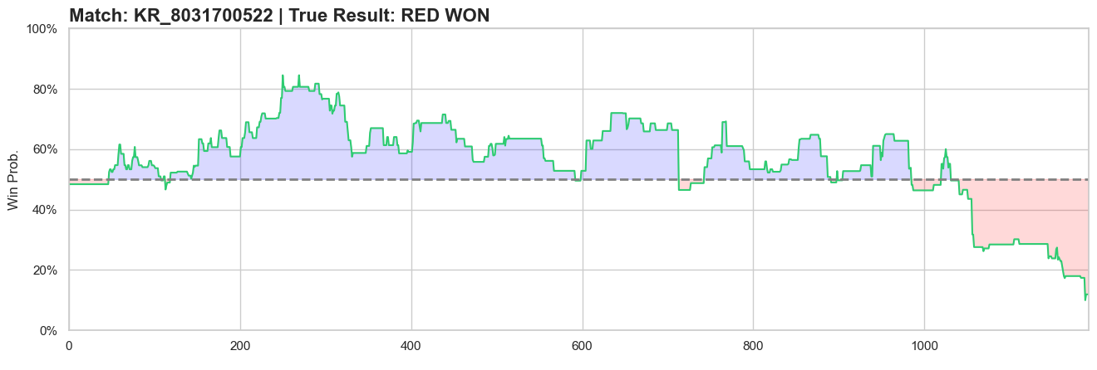
Despite the theoretical advantages of sequential modeling for such deeply time-dependent data, the Long Short-Term Memory (LSTM) network fell short of expectations during the validation phase. While recurrent architectures are designed to retain historical context, the LSTM struggled to generalize effectively, resulting in suboptimal predictive performance compared to the tree-based ensembles. This underperformance is primarily attributed to severe overfitting. The network likely memorized training sequences due to the exceptionally high dimensionality of the feature space combined with the inherent stochastic noise present within the micro-level event logs. The progression of training and validation metrics highlighting this generalization failure and subsequent overfitting is documented in Figure 8. Addressing these limitations to successfully train a generalized, high-performing LSTM architecture—potentially through aggressive dimensionality reduction or advanced regularization techniques—remains a key objective for future work. Consequently, the champion-aware XGBoost model proved to be the most robust, interpretable, and reliable framework for real-time win probability estimation in this project.
Figure 7: Real-time win probability trajectory of a sample match, demonstrating the model's instantaneous responsiveness to timestamp-based in-game events
Figure 8: Validation metrics for the LSTM network, exhibiting signs of overfitting on the high-dimensional event sequences

Summary and Conclusions

This project addressed the problem of estimating win probability in League of Legends matches based on in-game data. The task is particularly relevant due to the dynamic and complex nature of the game, where match outcomes evolve continuously from an initially uncertain state. A key question investigated in this work is how this uncertainty develops over time, and whether matches effectively start from an approximately balanced (50–50) state. Additional aspects of interest include the impact of structural factors such as the blue side advantage, as well as the role of champion selection in solo queue environments, where coordination between players is limited.
To address these questions, a complete data-driven analysis pipeline was developed. Data was collected using the Riot Games API, starting from Challenger-level ranked ladders on the Korean server. Match histories and detailed timeline data were retrieved and processed into a structured dataset. Both a prototype and a final, event-driven representation were constructed, enabling high-resolution temporal analysis. The final dataset contains several million observations and a large number of engineered features, including player-level statistics, cumulative metrics, and difference-based features.
Exploratory data analysis was performed to identify key patterns and validate assumptions about the data. The analysis confirmed that resource-related features, particularly gold and experience differences, are strongly associated with match outcomes. Additional findings include a measurable advantage for the blue side and the importance of early objective control. The temporal nature of the data was also highlighted, showing that the predictive value of features increases as the match progresses.
Several machine learning models were implemented to estimate win probability. These included a logistic regression baseline, gradient boosting models using XGBoost (with and without champion-specific features), and a sequence-based LSTM model to capture temporal dependencies. The results demonstrate that nonlinear models significantly outperform linear approaches, while the inclusion of champion-related information further improves predictive performance. Temporal modelling provides additional benefits, particularly in the early stages of the game.
Overall, the project demonstrates that win probability in League of Legends can be effectively modelled using data-driven methods. The results suggest that while matches may start from a near-balanced state, various in-game factors quickly introduce asymmetries that strongly influence the outcome. Resource advantages, objective control, and structural biases such as side selection all contribute to this process. The developed framework provides a foundation for further analysis and could be extended with additional data sources or more advanced modelling techniques in future work. Future work could include real-time prediction systems, cross-region analysis, or the integration of more advanced deep learning approaches.

References

Bibliography
[1] Riot Games API Documentation, https://developer.riotgames.com/, Accessed: 2026-05-16.

[2] MIT Sloan Sports Analytics Conference, "An Open-Sourced Optical Tracking and Advanced Metrics for Esports", https://www.sloansportsconference.com/research-papers/an-open-sourced-optical-tracking-and-advanced, Accessed: 2026-05-16.

[3] MIT Sloan Sports Analytics Conference, "Evaluating Player Actions in Professional Counter-Strike Using Temporal Heterogeneous Graph Neural Networks", https://www.sloansportsconference.com/research-papers/evaluating-player-actions-in-professional-counter-strike-using-temporal-heterogeneous-graph-neural-networks, Accessed: 2026-05-16.

[4] MIT Sloan Sports Analytics Conference (YouTube), "Esports Analytics Talk", https://youtu.be/Aof20FZgnmE, Accessed: 2026-05-16.

[5] T. Chen and C. Guestrin, "XGBoost: A Scalable Tree Boosting System", Proceedings of the 22nd ACM SIGKDD, 2016.

[6] S. Hochreiter and J. Schmidhuber, "Long Short-Term Memory", Neural Computation, 1997.

[7] C. Bishop, "Pattern Recognition and Machine Learning", Springer, 2006.

List of Accompanying Documentation, Files, and Deliverables:
The complete implementation of the project is available in the following public repository: https://github.com/BalazsBognar/League-of-Legends-Esport-Analytics-2026

Additionally, the processed datasets used in this project are available at: https://drive.google.com/drive/folders/1yNHhaW2RHFI1n5h6vi2FiUP1AAMo_jHb?usp=sharing

The repository contains:
- Data scraping and preprocessing notebook
- Exploratory data analysis and visualization scripts
- Machine learning models (Logistic Regression, XGBoost, LSTM)
- Evaluation scripts and generated figures

The dataset repository includes:
- Event-driven match data
- Champion mapping used for model training
- Sample dataset used for exploratory analysis

